**Final Report**

**Discrete Structures**

# Regulations

You should solve and submit this report to your theory Google classroom within 14 days, from the beginning of Dec 26th 2021 to the end of Jan 8th 2022. Late submission is not accepted.

This is an individual final report. Any case of plagiarism will get 0.

Students need to solve all the problems and submit a doc/docx file named by your StudentID, using our faculty’s format. English is required for high-quality classes. Format violations will cost from 10% to 50% of your total scores.

# Question 1: Euclid’s algorithm and Bezout’s identity

a. Using Euclid’s algorithm to calculate *gcd*(2021, 1000 + *m*) and *lcm*(2021, 1000 + m), where *m* is the last 3 digits of your student ID. For example, if your student ID is 52000**123** then you need to calculate *gcd*(2021, 1123) and *lcm*(2021, 1123).

b. Apply above result(s) in to find 5 integer solution pairs (x,y) of this equation:

2021x + (1000 + *m*)y = *gcd*(2021, 1123).

# Question 2: Recurrence relation

Solve the recurrence relation

*an = 8.an−1 – 15.an−2*

with *a0 = 5* and *a1 = m,*

where *m* is the last 2 digits of your student ID. For example, if your student ID is 520001**23** then *a1 = 23*.

# Question 3: Set

a. Create a set Γ of characters from your case-insensitive non-diacritical full name. For example, the set corresponding with “Tôn Đức Thắng” is Δ = {A, C, D, G, H, N, O, T, U}.

b. Find the union, intersect, non-symmetric difference, and symmetric difference of Γ and Δ.

# Question 4: Relations

Let ℜ be a binary relation defined on 2 integers as follow:

$$∀a,b∈\text{N (aRb↔}m\text{|(}a\text{.}b\text{))}$$

where  is the last 2 digits of your student ID.

For example, if your student ID is 520001**23** then the valid binary relation is

$$∀a,b∈\text{N (aRb↔}23\text{|(}a\text{.}b\text{))}$$

Is R reflexive, symetric, anti-symetric, transitive? Prove your answer.

# Question 5: Multiplicative inversion

a. Study and present your knowledge about Extended Euclidean algorithm to compute multiplicative inverses in modular structures.

b. Apply the algorithm to find (m+1)-1 (mod 101) where *m* is the last 2 digits of your student ID. For example, if your student ID is 520001**23** then *m= 23* and you need to find 24-1 (mod 101).

# Question 6: Kruskal’s algorithm

Propose a solution for circuit-checking in Kruskal's algorithm.

# Question 7: Eulerian circuit

a. Does the following graph have an Eulerian circuit or Eulerian path? Why?

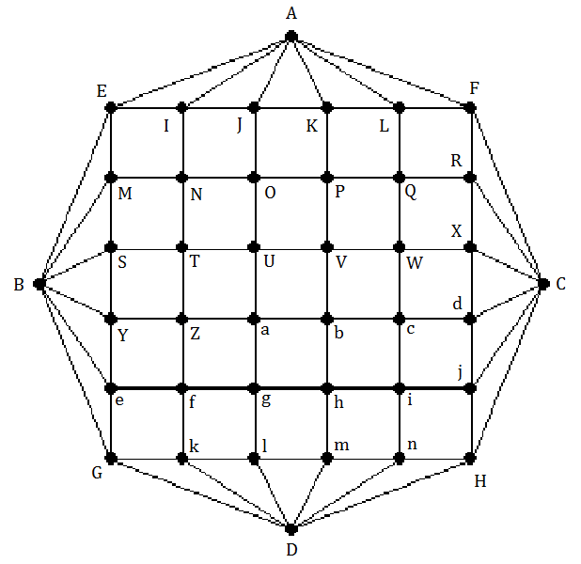

b. Study and present your knowledge about Hierholzer’s algorithm to find an Eulerian circuit.

c. If the graph has an Eulerian circuit, use Hierholzer's algorithm to find an Eulerian circuit of that graph when the initial circuit R1 is:

i. If $\overline{abcd}$% 4 = 0 then R1 is EINME

ii. If $\overline{abcd}$% 4 = 1 then R1 is abhga

iii. If $\overline{abcd}$% 4 = 2 then R1 is UVbaU

iv. If $\overline{abcd}$% 4 = 3 then R1 is XCdX

Where $\overline{abcd}$ is the 4-digit number combined by the last 4 digits in your StudentID*.* For example, Student ID 520H1234 has $\overline{abcd}$ = 1234.

# Question 8: Map coloring

Given this map:

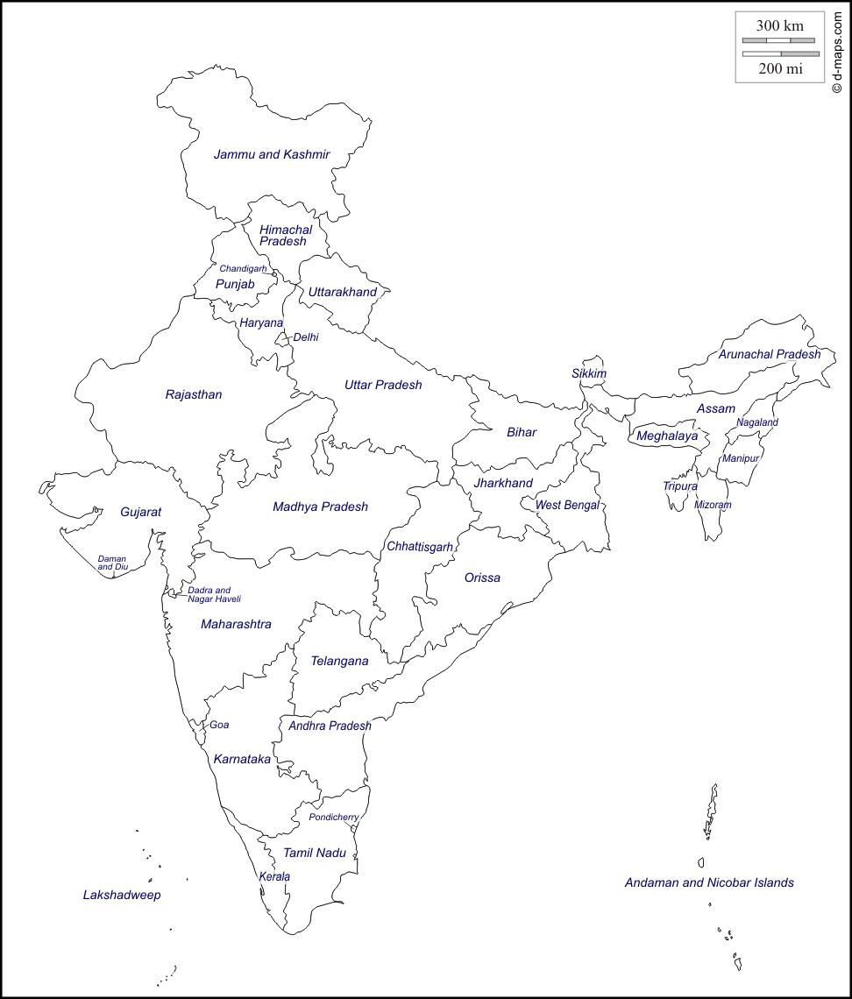

a. Modeling this map by a graph.

b. Color the map (graph) with a minimum number of colors. Present your solution step by step.

Let $\overline{abcd}$ be the 4-digit number combined by the last 4 digits in your StudentID*.* For example, StudentID 520H1234 has $\overline{abcd}$ = 1234.

i. If $\overline{abcd}$% 4 = 0 then start form Bihar.

ii. If $\overline{abcd}$% 4 = 1 then start form Orissa.

iii. If $\overline{abcd}$% 4 = 2 then start form Rajasthan.

iv. If $\overline{abcd}$% 4 = 3 then start form Meghalaya.

# Rubric

|  |  |  |  |  |  |  |  |
| --- | --- | --- | --- | --- | --- | --- | --- |
| **Criteria** | **Scale** | **1** | **2** | **3** | **Self-evalutaion** | **Reason** |  |
|  | **Score /10** | **0 score** | **1/2 score** | **Full score** |  |  |  |
| Question 1 | 1 | Do nothing or wrongly. | Correct gcd and lcm, but incorrect solutions of the Bezout’s identity. | Correct calculation, detailed explanation. |  |  |  |
| Question 2 | 1 | Do nothing or wrongly. | Correct calculation but wrong result or conclusion. | Correct calculation, detailed explanation. |  |  |  |
| Question 3 | 1 | Do nothing or wrongly. | Correct Γ but incorrect operations. | Correct calculation, detailed explanation. |  |  |  |
| Question 4 | 1 | Do nothing or wrongly. | Correct results but incorrect proofs. | Right results, detailed explanation. |  |  |  |
| Question 5 | 1 | Do nothing or wrongly. | Good study but incorrect applications. | Good study, right calculation, detailed explanation. |  |  |  |
| Question 6 | 1 | Do nothing or wrongly. | Reasonable but indetailed proposion. No illustration. | Reasonable detailed proposion with illustration. |  |  |  |
| Question 7 | 2 | Do nothing or wrongly. | a-Correct recognition, right explanation.  b,c-Good study but incorrect applications. | a-Correct recognition, right explanation.  b,c-Good study, right calculation, detailed explanation. |  |  |  |
| Question 8 | 2 | Do nothing or wrongly. | Correct modeling but wrong coloring. | Correct modeling but right coloring. |  |  |  |
| **Total** | 10 | Result | | | 0 |  |  |